Loren Eatery

This project is a simple Full Stack Point of Sale (POS) System developed using HTML, CSS, JavaScript, and PHP. The system is designed to help manage customer orders, product listings, and sales transactions in an easy and organized way. It provides a user-friendly interface for both customers and staff, allowing faster order processing and better transaction management. The project also demonstrates the integration of frontend and backend technologies to create a functional web-based application.

Objectives of the Website
- To develop a simple and user-friendly Point of Sale (POS) System.
- To manage customer orders and sales transactions efficiently.
- To organize product information and pricing in one system.
- To improve the speed and accuracy of order processing.
- To apply full stack web development using HTML, CSS, JavaScript, and PHP.
- To provide an easy-to-use interface for both staff and customers.

Tools and Technologies Used
- HTML – Used to create the structure of the website.
- CSS – Used for designing and styling the user interface.
- JavaScript – Used to add interactivity and dynamic functions.
- PHP – Used for backend development and server-side processing.
- MySQL – Used to store and manage product, order, and transaction data.
- XAMPP – Used as the local server environment for running PHP and MySQL.
- Visual Studio Code – Used as the code editor for developing the project.
- Artificial Intelligence (AI) Tools – Used to assist in faster development, debugging, code suggestions, and improving productivity during the creation of the system.

Website Features and Functions
- User-friendly and responsive interface.
- Product listing and price management.
- Add to cart and order processing system.
- Automatic total price calculation.
- Queue number generation for customer orders.
- Order status management (Pending, Preparing, Completed, etc.).
- Sales and transaction recording.
- Date and time tracking for orders.
- Admin dashboard for managing products and transactions.
- Database integration using MySQL for data storage.
- Real-time interaction using JavaScript.
- Fast and efficient processing using PHP backend functions.

Database Structure
The Loren Eatery POS System uses a MySQL database to manage and organize all system data efficiently. The database is designed with multiple related tables to handle menu management, customer orders, queue tracking, administrator accounts, and activity monitoring.

Main Database Tables
- Admins Table (admins)
Stores administrator and cashier account information including username, password, email, role, and login records.
- Categories Table (categories)
Stores menu categories such as Burgers, Chicken, Fries, Pasta, Drinks, and Desserts.
- Menu Items Table (menu_items)
Stores all menu products including item name, description, price, image, availability status, bestseller status, and category relationship.
- Queue Tracker Table (queue_tracker)
Manages daily queue numbering for customer orders to maintain organized order processing.
- Orders Table (orders)
Stores customer order details including queue number, customer name, payment information, order status, notes, estimated waiting time, and order date.
- Order Items Table (order_items)
Stores the specific products included in each order together with quantity, price, and subtotal information.
- Activity Logs Table (activity_logs)
Records admin and cashier activities within the system for monitoring and security purposes.
Database Functions
- Maintains organized storage of products and transactions.
- Supports real-time order and queue management.
- Tracks customer payments and order status updates.
- Manages admin and cashier accounts securely.
- Records user activities for monitoring and auditing.
- Uses relational database connections through primary and foreign keys to ensure data consistency and integrity.
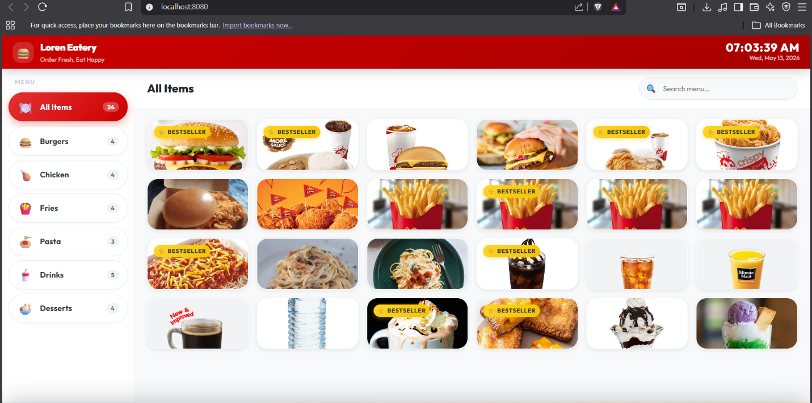
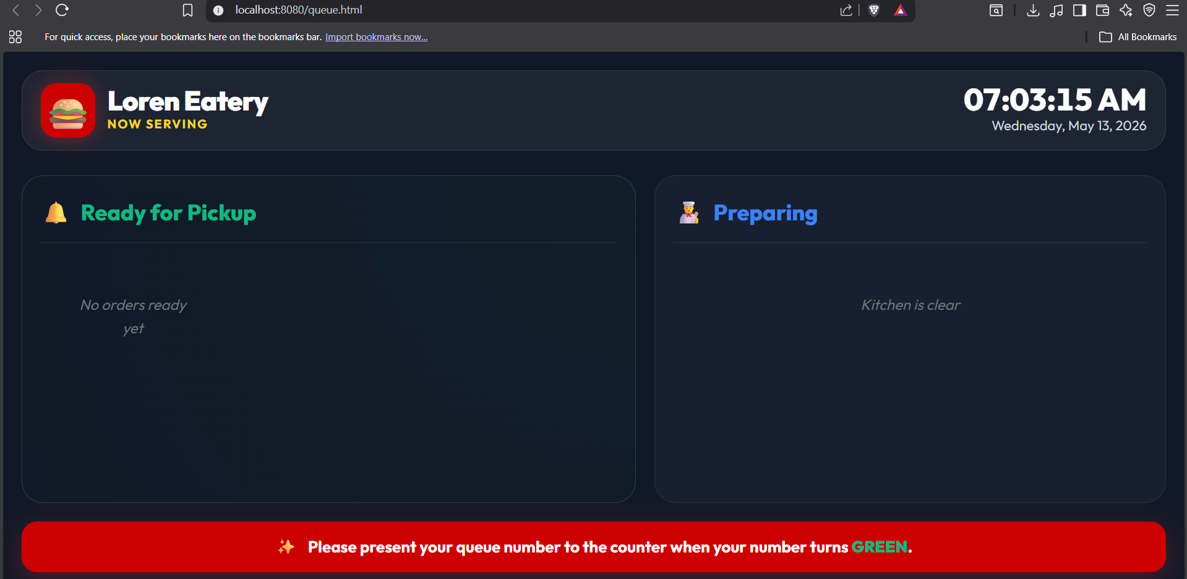

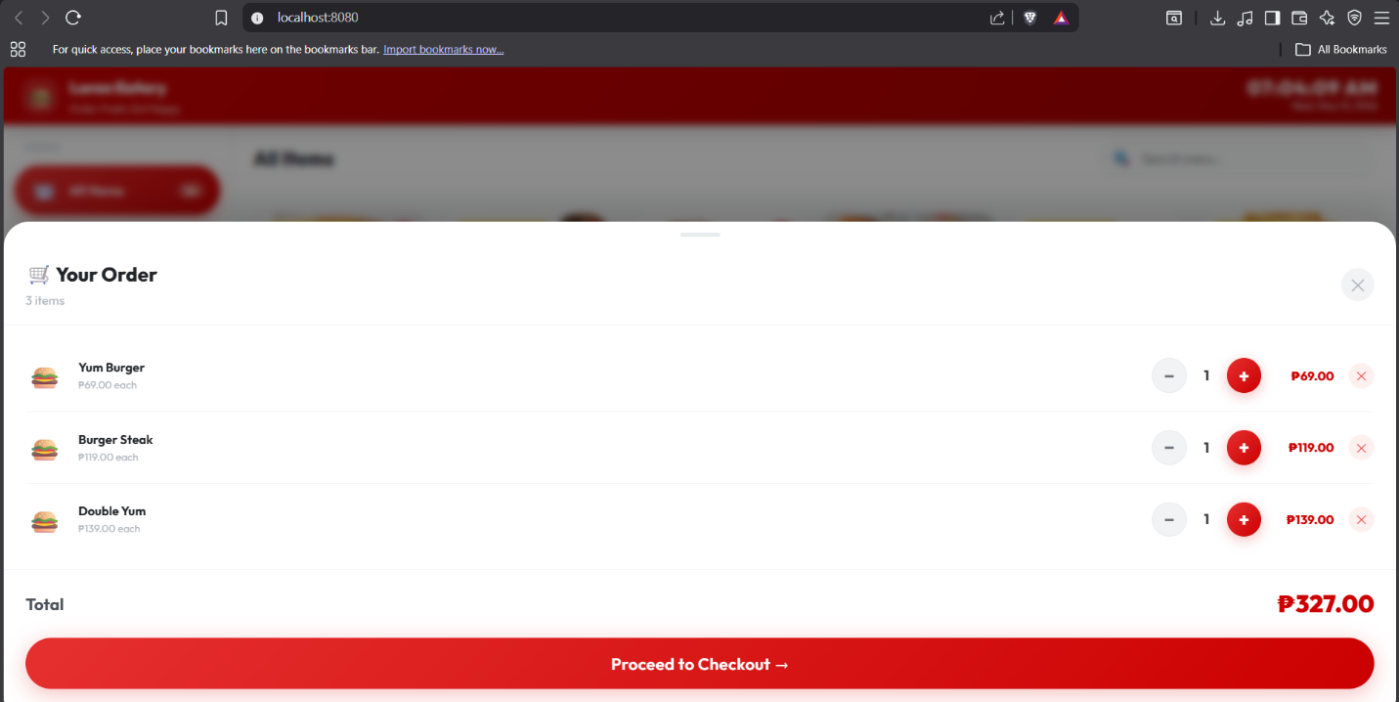
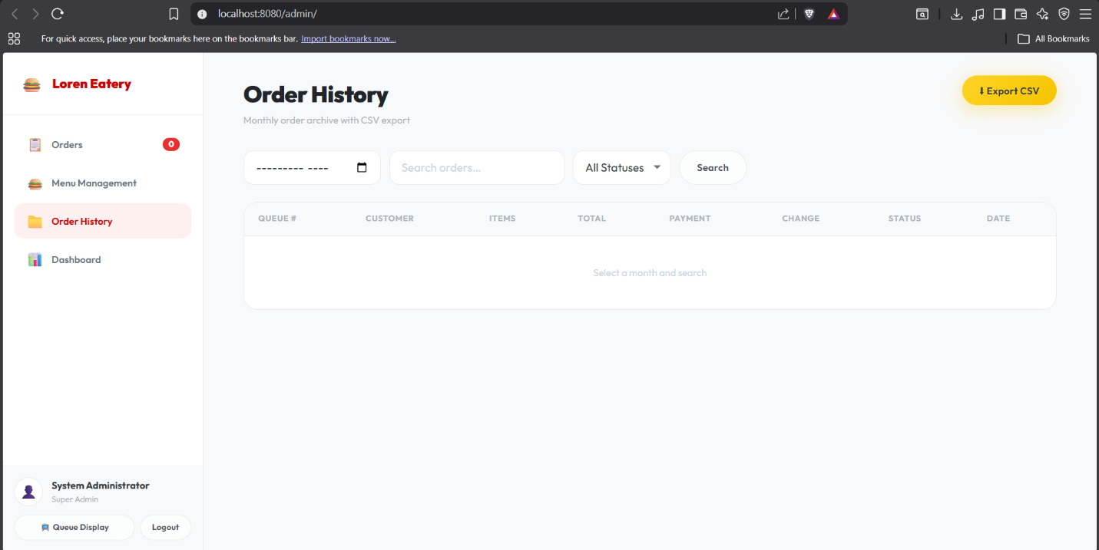

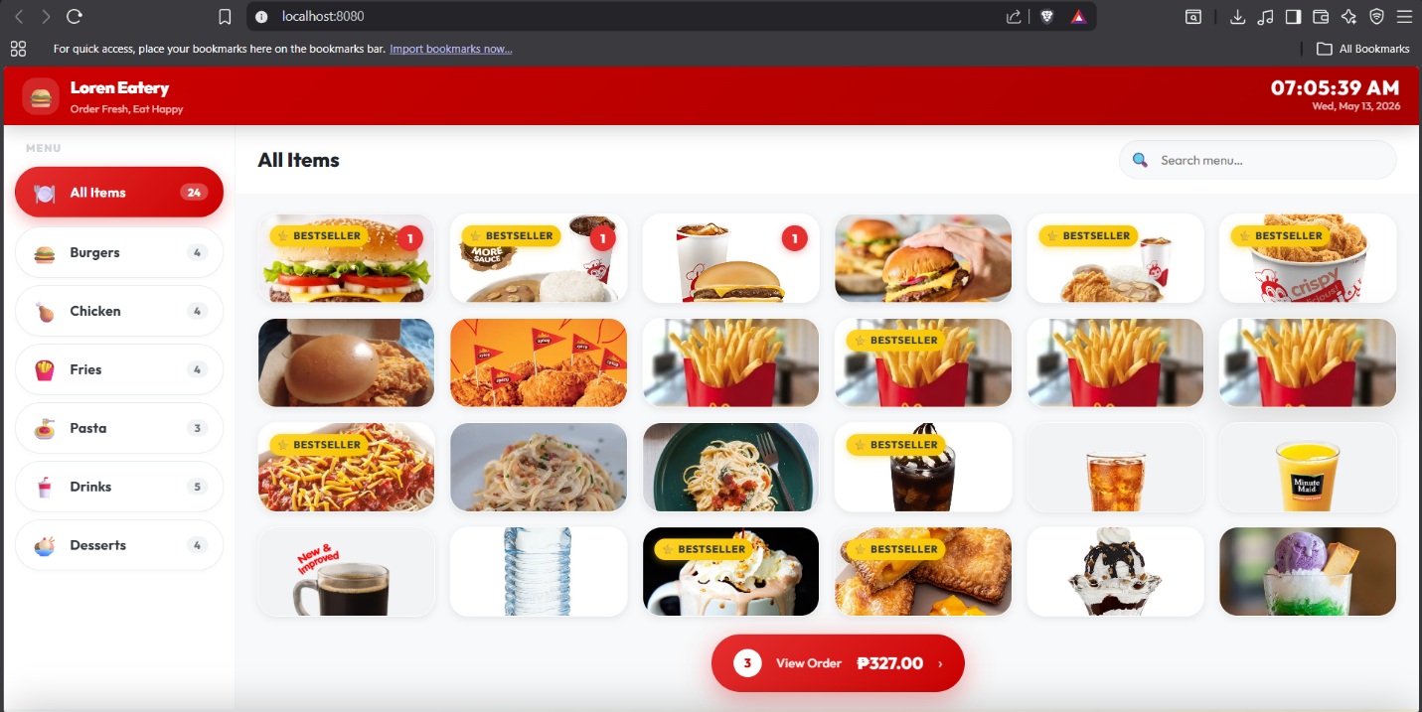
Conclusion
In conclusion, the Loren Eatery Point of Sale (POS) System successfully achieved its goal of creating a simple, efficient, and user-friendly web-based ordering and transaction management system. By using full stack web development technologies such as HTML, CSS, JavaScript, PHP, and MySQL, the project was able to provide important features including product management, queue tracking, order processing, and sales recording.
The system helps improve the speed, accuracy, and organization of customer transactions while also providing a convenient experience for both staff and customers. Through database integration and backend processing, the application can securely store and manage data in real time. Additionally, the project enhanced the developers’ skills in frontend and backend programming, database management, and system integration.

